Join and Set Exercises:

Use the Salespeople, Customers, and Orders tables to answer the following queries.
Recreate the tables to ensure your data is correct.
It may help you to see how the tables are interrelated:
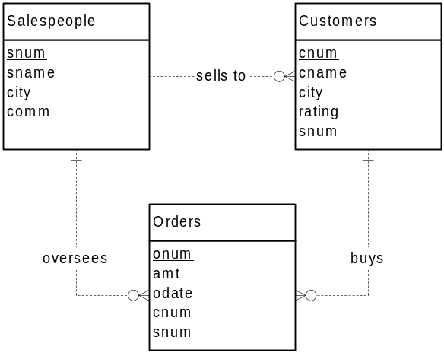

- List each order number followed by the name of the customer who made the order.

- List all customers serviced by salespeople with a commission above 12 percent. Output the customer’s name, the salesperson’s name, and the salesperson’s commission.

- Calculate the amount of the salesperson’s commission on each order by a customer with a rating over 100.

- Add the following rows to the Salespeople and Customers tables, you can copy and paste, but you might need to edit the paste if pastes in the wrong characters for quotes from MS Word:
INSERT INTO Salespeople (salespersonnum, salespname, salespcity, commission) VALUES (1020, 'Wing', 'Bangkok', .11);
INSERT INTO Customers (customernum, cusname, cuscity, cusrating, salespersonnum)VALUES (2009, 'Christy', 'Bangkok', 200, NULL);
COMMIT;

And create and populate an “Employees” table, as follows:
CREATE TABLE Employees
(empno NUMBER(4) NOT NULL PRIMARY KEY,
name VARCHAR2(20) NOT NULL,
manager NUMBER(4) NULL REFERENCES Employees(empno)
);
INSERT INTO Employees (empno, name, manager)
VALUES (2007, 'Atali', NULL);
INSERT INTO Employees (empno, name, manager)
VALUES (1003, 'Terrence', 2007);
INSERT INTO Employees (empno, name, manager)
VALUES (1688, 'McKeen', 1003);
INSERT INTO Employees (empno, name, manager)
VALUES (2002, 'Collier', 2007);
COMMIT;

- List all salespeople (number and name), and show the orders (number and amount) they were involved with on October 3, 2000. All salespeople should be listed, even if they were not involved in a sale on that day. Order the results by salesperson’s name.

- List all customers (number and name), and the salespeople (number and name) that are assigned to them. All salespeople should be listed, even if they are not assigned to any customers.

- List all customer numbers and salespeople numbers, and the matches between them if any. All customers should be displayed, even if they don’t have a salesperson; all salespeople should be displayed, even if they don’t have a customer.

- Revise the following query so that employees who have no managers will be included in the output:
SELECT e.empno, e.name, m.name
FROM Employees e, Employees m
WHERE e.manager = m.empno;

- List the salespeople (number and name) and customers (number and name) that are located in London.

- Create a union of two queries that shows the names, cities and ratings of all customers. Those with a rating of 200 or greater will also have the words “HIGH RATING” displayed, while those with a rating lower than 200 or a NULL rating, will have the words “LOW RATING” displayed.

- Write a statement that produces the name and number of each salesperson and each customer with more than one order. Put the results in alphabetical order.

- Show all combinations of customers that are in the same city as a salesperson. Hint: You can join on columns other than the key.

- Find all orders by customers not located in the same city as the salesperson who took the order.
- List all pairs of salespeople who are assigned to the same city. For each salesperson, display the number, name, and city. Exclude the combination of salespeople with themselves. Show each combination of salespeople only once – that is, don’t show both (Smith, Jones) and (Jones, Smith).

- List the names and cities of all customers with the same rating as customer number 2001.

